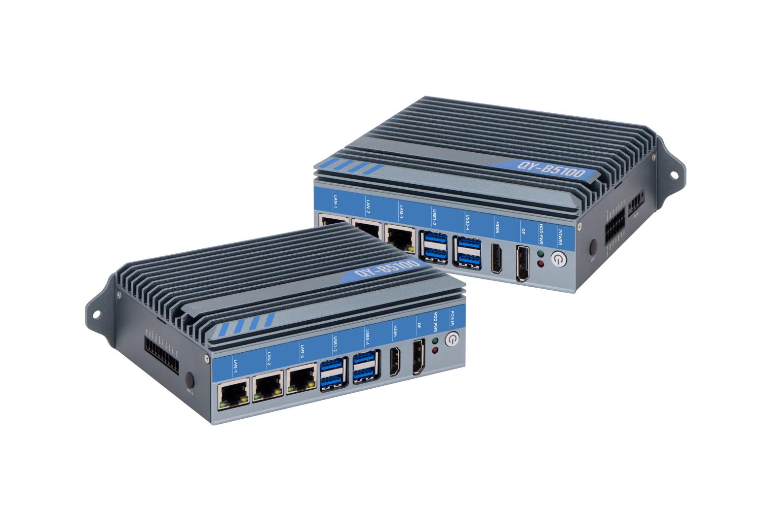
Industrial Mini PC
QY-B5100
Rail Mount Series

Products Features:
- Industrial-Grade Embedded Fanless Mini PC
- Intel Celeron and Core 4/6/7/8/10th-i3 / i5 / i7 CPU
- 3*LAN, 4*USB, 4*COM, 1*HDMI, 1*DP, 8*GPIO
- 1*Mini PCIE Expansion Slot, Support 4G and WIFI Module
- DC 9-36V Power Input With Overvoltage Protection
- -30℃~70℃ Temperature Can Keep 24/7 Work Stably
- Anti-Static, Anti-Pulse, Anti-Surge, Anti-Radiation
QY-B5100
1.Mother Board Specification:
Model | QY-B5100
CPU | J1900  i5-4260U | J6412  i3-7100U  i5-6200U / 7200U / 8260U / 10210U  i7-7500U / 10610U
Memory^{[1]} | 1*DDR III RAM Slot, Up to 8GB | 1*DDR IIII RAM Slot, Up to 16GB
Storage | 1*MSATA SSD Slot
Display^{[2]} | 1*HDMI: Resolution up to 4096*2304@24Hz  1*DP: Resolution up to 4096*2304@60Hz
Expansion | 1*Mini PCIE Slot, Support 4G and WIFI module
Ethernet | 3*Intel i211V LAN Chip (10 / 100 / 1000 Mbps, RJ-45 Type)
USB | 4*USB 3.0 (Type-A)
COM | 2*RS-232 / 422 / 485 (Phoenix Terminal Type)  2*RS-232 (Phoenix Terminal Type)
GPIO | 8 ports GPIO (4*GPI+4*GPO, Phoenix Terminal Type)
Notes:
[1]: The maximum memory capacity and the maximum capacity per strip supported by this motherboard depend on the CPU.
[2]: The maximum resolution and frame rate of the display interface output depends on the CPU.

QY-B5100
2.Device Specification:
Watch Dog | Support
Power Input | DC 9-36V With Overvoltage Protection
Power Input | Support Auto-Start
Power Input | 3 Pin Phoenix Terminal Type DC Plug
Working Temperature | -30℃~70℃, Support 24/7 Working
Structure | Fully Enclosed Aluminum Alloy Material
Heat Dissipation | Fanless Design, Conduction Heat Dissipation
Installation | Desktop / Embedded / Wall / Rail Mount
Size | 260mm*150mm*65mm
System | Windows and Linux

QY-B5100
3.Ordering Information:
Model | CPU | LAN | USB | COM | Display | RAM | SSD | Expansion | Power
QY-B5100 | J1900 / 4th | 3 | 4 | 2*RS-232/422/485  2*RS-232 | 1*HDMI  1*DP | 1*DDR 3  Up to 8GB | 1*MSATA | 1*Mini PCIE | DC 9-36V
QY-B5100 | J6412/6th/7th |  |  |  |  | 1*DDR 4  Up to 16GB | 1*MSATA | 1*Mini PCIE | DC 9-36V
QY-B5100 | 8th / 10th |  |  |  |  | 1*DDR 4  Up to 32GB | 1*MSATA | 1*Mini PCIE | DC 9-36V

4.CPU Information:

CPU | Specification
J1900 | 4 core, 4 total threads, 2.00 GHz to 2.42GHz, 2 MB cache | Max to 8GB for 1*DDR 3 Slot
i5-4260U | 2 core, 4 total threads, 1.40 GHz to 2.70GHz, 3 MB cache | Max to 16GB for 1*DDR 3 Slot
J6412 | 4 core, 4 total threads, 2.00 GHz to 2.60GHz, 1.5 MB cache | Max to 16GB for 1*DDR 4 Slot
i5-6200U | 2 core, 4 total threads, 2.30 GHz to 2.80GHz, 3 MB cache | Max to 16GB for 1*DDR 4 Slot
i3-7100U | 2 core, 4 total threads, 2.40 GHz, 3 MB cache | Max to 16GB for 1*DDR 4 Slot
i5-7200U | 2 core, 4 total threads, 2.50 GHz to 3.10GHz, 3 MB cache | Max to 16GB for 1*DDR 4 Slot
i7-7500U | 2 core, 4 total threads, 2.70 GHz to 3.50GHz, 4 MB cache | Max to 16GB for 1*DDR 4 Slot
i5-8260U | 4 core, 8 total threads, 1.60 GHz to 3.90GHz, 6 MB cache | Max to 32GB for 1*DDR 4 Slot
i5-10210U | 4 core, 8 total threads, 1.60 GHz to 4.20GHz, 6 MB cache | Max to 32GB for 1*DDR 4 Slot
i7-10610U | 4 core, 8 total threads, 1.80 GHz to 4.90GHz, 6 MB cache | Max to 32GB for 1*DDR 4 Slot

QY-B5100
5.System Information:

CPU | System
J1900 | Windows 7 / 10 and Linux
4th / 6th / 7th | Windows 7 / 10 and Linux
J6412 | Windows 10 / 11 and Linux
8th / 10th | Windows 10 / 11 and Linux
RAM | DDR 3 | 4GB / 8GB
RAM | DDR 4 | 4GB / 8GB / 16GB / 32GB
Storage | MSATA | 64GB / 128GB / 256GB / 512GB / 1TB
GSM Module | 4G | 4G+GPS
WIFI Module | 7260AN / 7260AC / AX210
6.Fittings Information:

7.Package List:
Adapter | 1*12V 5A Adapter
Power Cable | 1*Power Cable
Terminal | 10 Pin phoenix terminal for GPIO
Terminal | 14 Pin phoenix terminal for COM

QY-B5100
8.Dimensions:

